**Project Design Phase-II**

**Data Flow Diagram & User Stories**

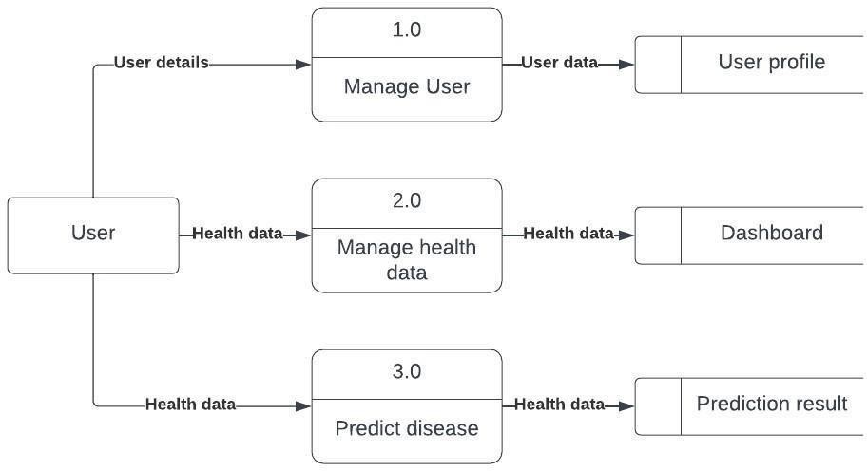

|  |  |
| --- | --- |
| Date | 21 October 2022 |
| Team ID | PNT2022TMID03674 |
| Project Name | Visualizing and Predicting Heart Diseases with an Interactive Dashboard |
| Maximum Marks | 4 Marks |

**Data Flow Diagrams:**

A Data Flow Diagram (DFD) is a traditional visual representation of the information flows within a system. A neat and clear DFD can depict the right amount of the system requirement graphically. It shows how data enters and leaves the system, what changes the information, and where data is stored.

**Data Flow Diagram for Heart Disease Prediction Dashboard:**

**Flow:**

1. User creates an account in the application.
2. User enters the medical records in the dashboard.
3. User can view the visualizations of trends in the form of graphs and charts for his/her medical records with the trained dataset.
4. User can view the accuracy of probability of occurrence of heart disease in the dashboard.

**User Stories:**

|  |  |  |  |  |  |  |
| --- | --- | --- | --- | --- | --- | --- |
| **User Type** | **Functional**  **Requirement (Epic)** | **User**  **Story**  **Number** | **User Story / Task** | **Acceptance criteria** | **Priority** | **Release** |
| Customer (Web user) | Registration | USN-1 | As a user, I can register for the application by entering my email, password, and confirming my password. | I can access my account / Dashboard | High | Sprint-1 |
|  |  | USN-2 | As a user, I will receive confirmation email once I have registered for the application | I can receive confirmation email & click confirm | High | Sprint-1 |
|  | Login | USN-3 | As a user, I can log into the application by entering email & password | I can access my account  / Dashboard whenlogged in | High | Sprint-1 |
| Customer (Web user) | Dashboard | USN-4 | User can view his/her complete medical analysis and accuracy of disease prediction | I can view my medical  analysis in the dashboard | High | Sprint-2 |
|  |  | USN-5 | User can view the accuracy of occurrence of heart disease | I can view the accuracy  of heart disease in the dashboard | High | Sprint-2 |
| Customer Care Executive | Helpdesk | USN-6 | As a customer care executive, he/she can view the customer queries. | I can post my queries in the dashboard | Medium | Sprint-3 |
|  |  | USN-7 | As a customer care executive, he/she can answer the customer queries. | I can get support from helpdesk | High | Sprint-3 |
| Administrator | User Profile | USN-8 | As an admin, he/she can update the health details of users. | I can view my updated health details. | High | Sprint-4 |

|  |  |  |  |  |  |  |
| --- | --- | --- | --- | --- | --- | --- |
| **User Type** | **Functional**  **Requirement (Epic)** | **User**  **Story**  **Number** | **User Story / Task** | **Acceptance criteria** | **Priority** | **Release** |
|  |  | USN-9 | As an admin, he/she can add or delete users. | I can access my account  / Dashboard whenlogged in | High | Sprint-4 |
|  |  | USN-10 | As an admin, he/she can manage the user details. | I can view the organized data of myself. | High | Sprint-4 |